### **47MapReduce and PageRank**

**Question 1**:

**Suppose our input data to a map-reduce operation consists of integer values (the keys are not important). The map function takes an integer *i* and produces the list of pairs (*p*,*i*) such that *p* is a prime divisor of *i*. For example, map(12) = [(2,12),(3,12)].**

**The reduce function is addition. That is, reduce(*p*,[*i*1,*i*2,...,*ik*]) is (*p*,*i*1+*i*2+...+*ik*).**

**Compute the output, if the input is the set of integers 15, 21, 24, 30, 49.**

prime no:2,3,5,7,11,..........  
15:[3,15],[5,15]  
21:[3,21],[7,21]  
24:[2,24],[3,24]  
30:[2,30],[3,30],[5,30]  
49:[7,49]  
by combining all common elements part i.e compare left element and add rightmost element of that to get the solution.  
[2,(24+30)],[3,(15+21+24+30)],[5,(15+30)],[7,(21+49)]  
so, Output is ([2,54],[3,90],[5,45],[7,70])

**Question 2**:

Consider three Web pages with the following links:

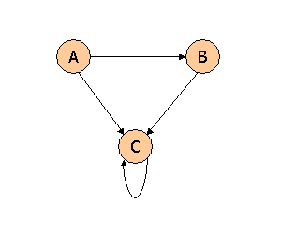

Suppose we compute PageRank with a β of 0.7, and we introduce the additional constraint that the sum of the PageRanks of the three pages must be 3, to handle the problem that otherwise any multiple of a solution will also be a solution. Compute the PageRanks *a*, *b*, and *c* of the three pages A, B, and C, respectively.

Value of a, b, or c as we iterate are: a

All PageRank is multiplied by .7 before distribution, and .3 is then added to each

new PageRank.

a = β(0) + (1-β) → .3

b = β(a/2) + (1 - β) → .7(a/2) + .3

c = β(a/2 + b + c) + (1 - β) → .7(a/2 + b + c) + .3

That immediately tells us a = .3. We can then use the second equation to discover b

= .7(.3/2 ) + .3 = .405. Finally, the third equation simplifies to c = .7(.555 + c) + .3,

or .3c = .6885. From this equation we get c = 2.295

To compute the subs of each two of the variables:

a + b = .705, a + c = 2.595, and b + c = 2.7

**Question 3**:

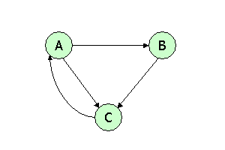

Suppose we compute PageRank with β=0.85. Write the equations for the PageRanks *a*, *b*, and *c* of the three pages A, B, and C, respectively.

We Know,

a = β * c + (1 - β) 1/3

b = β * a/2 + (1 - β) 1/3

c = β * (a/2 + b) + (1 − β)1/3

Here,

a = 0.85*c + (1 - 0.85) 1/3, a = 0.85c + 0.05

b = 0.85*0.5*a + 0.05, b = 0.425a + 0.05

c = 0.85*[0.5*a + b] + 0.05, c = 0.425a + 0.85b +0.05

**Question 4**:



Assuming no "taxation," compute the PageRanks *a*, *b*, and *c* of the three pages A, B, and C, using iteration, starting with the "0th" iteration where all three pages have rank *a = b = c* = 1. Compute as far as the 5th iteration, and also determine what the PageRanks are in the limit

a = c

b = a/2

c = a/2 + b

At 0th iteration: a = 1; b = 1; c = 1

At 1st iteration: a = c = 1; b = 1/2; c = 1/2 + 1 = 3/2

At 2nd iteration: a = c = 3/2; b = a/2 = 1/2; c = 1/2 +1/2 = 1

At 3rd iteration: a = c = 1; b = a/2 = (3/2)/2; c = 3/4 + 1/2 = 5/4

At 4th iteration: a = c = 5/4; b = a/2 = 1/2; c = 5/4

At 5th iteration: a = 5/4; b = 5/8; c = 9/8

.